

SYMBIOSIS INTERNATIONAL (DEEMED UNIVERSITY)
(Established under section 3 of the UGC Act 1956)
Re-accredited by NAAC with “A” Grade

Name of the Student: Sneha Sah PRN: 25070122189
Semester: 3 Year: AY 25-29

ASSIGNMENT No: 12

TITLE: Write a Java program to create and use user-defined packages.

Problem Statement: Write a Java program to create and use user-defined packages.
Theory: Packages are used to organize related classes and interfaces into namespaces. User-defined packages improve code organization, reduce naming conflicts, and enhance reusability. They also support access protection and modular application development. Java packages simplify project management by grouping logically related components together. Largescale software systems extensively use packages.
Exercise
1.Create a Java program by developing user-defined packages for a College Management System. Create separate packages for student and faculty details, and display their information using classes from these packages.

Program Structure:
CollegeManagement
│
├── student
│ └── Student.java
│
├── faculty
│ └── Faculty.java
│
└── CollegeManagement.java
Source code:

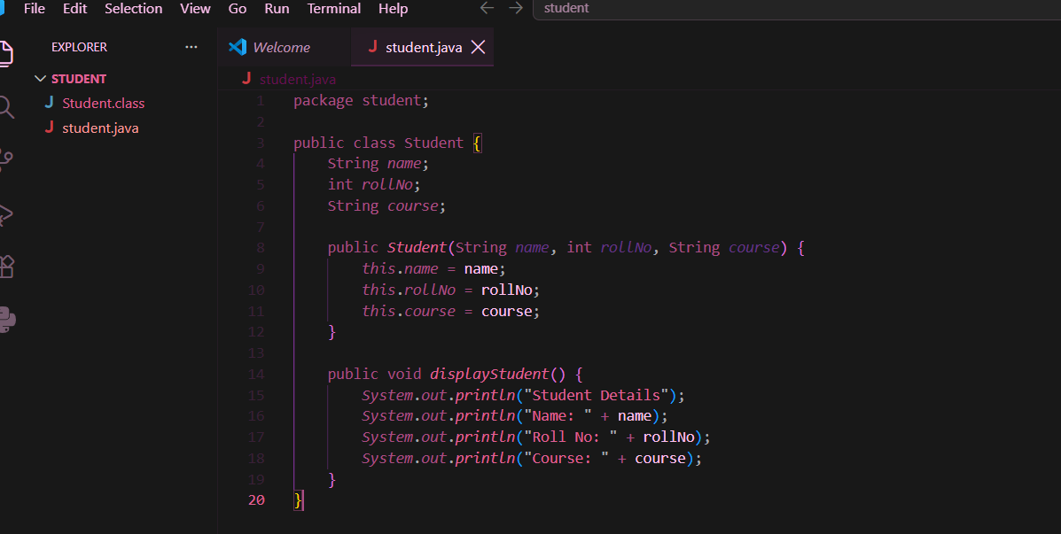
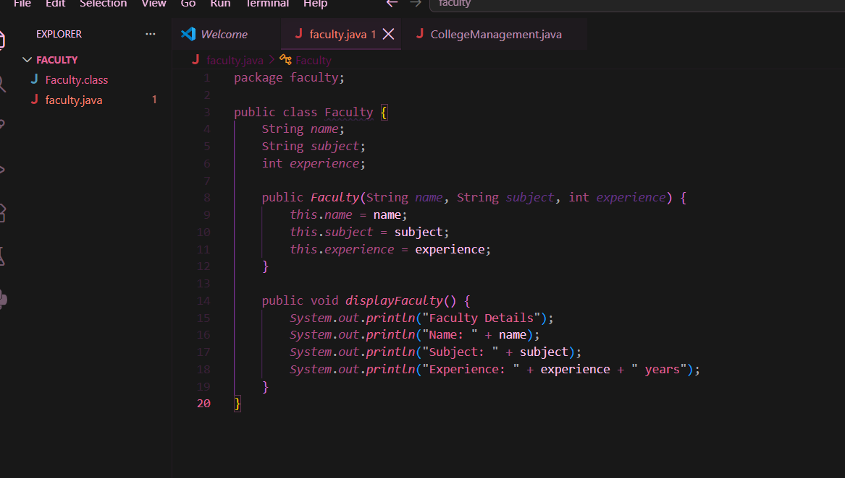
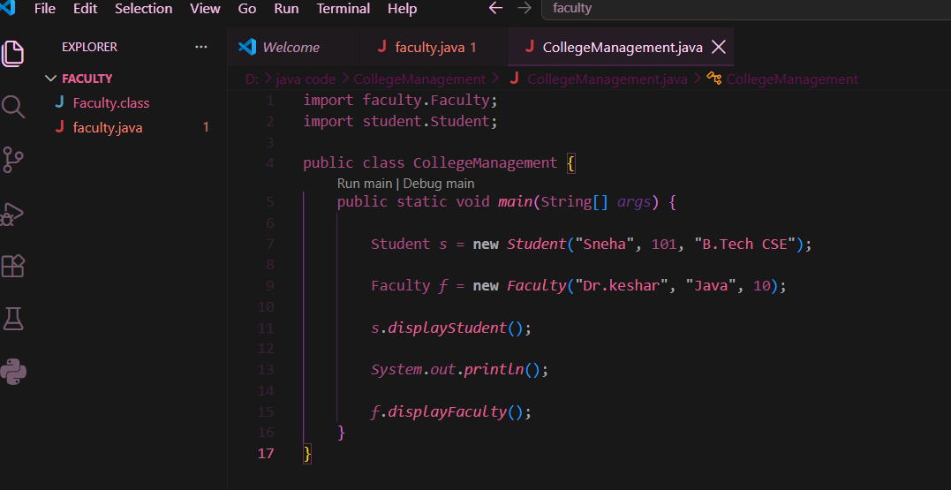

Output:
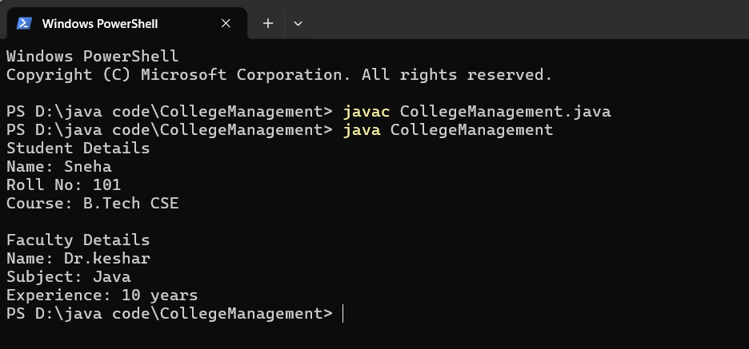

2. Create a Java program by developing a user-defined package named library that contains a class to store and display book details such as book ID, title, author, and price. Import the package into the main program and display the book information.

Program Structure:

LibraryManagement
│
├── library
│ └── Book.java
│
└── LibraryManagement.java

Source code:

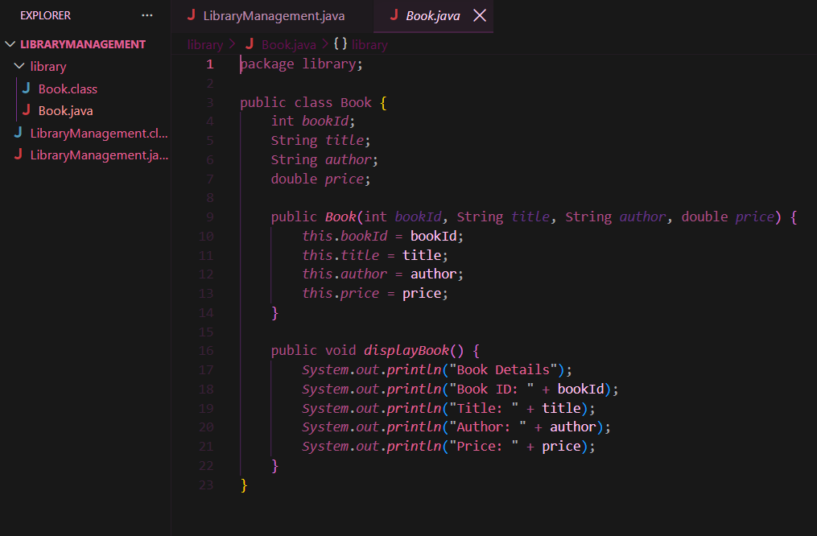
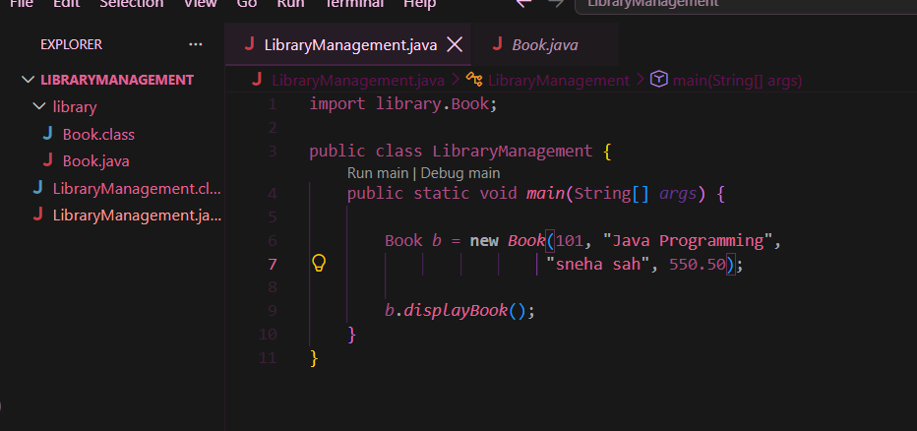

Output:

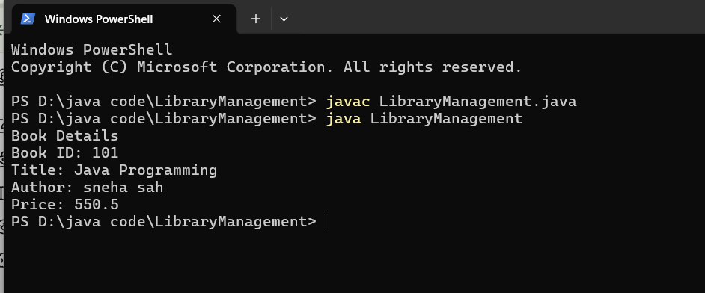

Conclusion
Thus, the experiment was successfully completed by creating and using user-defined packages in Java. We created separate packages for student, faculty, and library details, and accessed their classes in the main program using the import statement. This experiment helped us understand how packages improve program organization, code reusability, and modularity in Java.

